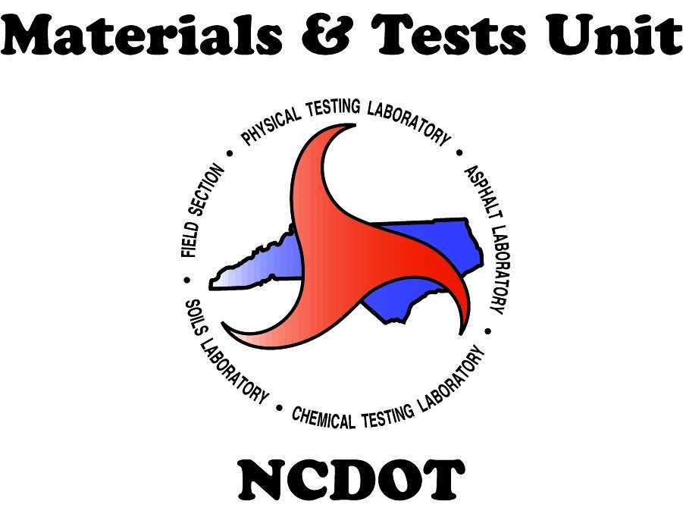

Standard Operating Procedure (SOP)

Approval Process – New Ready-Mixed Concrete Facility

1. Purpose
This SOP outlines the steps for obtaining approval as a ready-mixed concrete producer on the NCDOT Approved Producer List (APL). It applies to new producers and those removed from the APL for more than three months.

2. Scope
This process applies to ready-mixed concrete producers seeking to supply concrete to NCDOT or projects within NCDOT right-of-way. It does not apply to Precast, Prestress, or Volumetric operations.

3. Procedure

Step 1: Third-Party Inspection (NRMCA)
- Each producer must complete a third-party inspection by the National Ready Mixed Concrete Association (NRMCA).
Note: Plants used for PCCP (Portland Cement Concrete Pavement) do not require a 3rd party inspection.
- Use the link to locate an approved inspector: https://www.nrmca.org/certifications/plant-and-truck-certification-program/
- The producer is responsible for scheduling and funding the inspection, as well as ensuring the NRMCA inspection is completed.
- All required sections must be successfully completed as part of the NRMCA approval process.
- The NRMCA inspector must complete the “NCDOT Addendum” during the visit.

Step 2: Submission to NRMCA
- After the inspection, the producer’s Quality Control (QC) Manager must submit all documentation to NRMCA for final approval.

Step 3: Ownership Form Completion
- The producer’s QC Manager completes the Ownership Update Form.

Step 4: Submission to NCDOT
- Upon final NRMCA approval, the facility representative must email the following documentation to readymixinspections@ncdot.gov :
- Full third-party inspection package, approved and signed by NRMCA, with the Certificate also signed by
plant officials.
- Completed NCDOT Addendum.
- Ownership Update Form.

Step 5: Vendor System Activation
- The facility will be registered and activated in the Vendor system and assigned an RM number.
- However, the facility will remain in an expired status until the full approval process is completed, which includes the M&T facility Audit and materials sampling and evaluation process.
- The RM number is used to identify the facility and its mix designs during the approval process.

Step 6: Mix Design Submission
- An NCDOT-certified Mix Design Technician must submit the mix designs using electronic Form 312U to concretedesigns@ncdot.gov for approval.
- The fillable PDF version of the Form 312U is located on the Materials & Tests website: https://connect.ncdot.gov/resources/Materials/MaterialsResources/Form%20312U%20Rev06-20.pdf
- For mixes submitted for pre-approval, please indicate the RM number on Form 312U and note that the mix design is for a “New Facility”.

Step 7: Facility Audit Request
- The facility representative is responsible for contacting the local M&T Section Materials Specialist (SMS) to schedule a facility audit.

Step 8: Initial Audit by SMS
- The SMS (or designated representative) shall conduct the full facility audit process, including a visual inspection of aggregate stockpiles and/or bins, collection of materials samples, and verification of documentation.
Materials requiring sampling include:
- Cementitious materials,
- Aggregates
- Water (if required).
- The SMS (or designated representative) should enter samples in HiCAMS as “Informational” with a note: “Sample for New Plant Approval”.
- Samples must be sent to the Central Lab Structural Materials – Chemical Section.

Step 9: Final Submission to NCDOT
- The Chemical Lab will analyze and evaluate the cementitious material(s) and water (if applicable) samples obtained from the Ready-Mixed Concrete facility.
- After performing fingerprint analysis to confirm the sources of cement and any other cementitious materials (if applicable), a Chemical Lab representative will notify the SMS.
- The SMS shall submit the M&T Facility Audit Report and test results to readymixinspections@ncdot.gov .
- After reviewing the documentation and initial tests results the facility will be placed in “Active” status in the Vendor system.
- The SMS is responsible for verifying the final test results.
Note: If any final test result fails, the status of the Ready-Mixed concrete facility will be determined on a case-by-case basis.

Step 10: Reporting of Results
- The SMS informs the Ready-Mixed Concrete facility of the final audit sample results.

